Investigation of Evolving Neural Networks through Augmenting Typologies
There are many different machine learning models out in the world today, and expanding on the different techniques used is important in growing an understanding and capability to work with and advance different machine learning techniques.

NEAT Short:
NEAT stands for Neurological Evolution of Augmenting Typologies. ‘

Described advantages:
- employing a principled method of crossover of different typologies
- protecting structural innovation using specialization
- incrementally growing from minimal structure

+ Uses Genetics and natural selection to gradually build the best neural network.
- Creating class Temples for simulation

Concerns:

Required Simulation Functionality:

Items
Genes
Gene struct contains the Innovation number associated with the mutation.
- NodeGene_t
  - Innovation Number
  - Node Number
  - Disabled Flag

- EdgeGene_t
  - Innovation Number
  - In/Out Nodes
  - Disabled Flag

Innovation Number
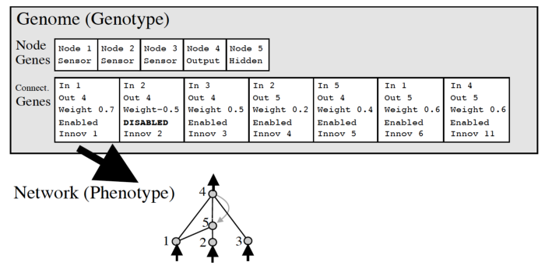
https://miro.medium.com/max/700/0*Kze4g6cLA3maofxq.png

Steps:
- Simulation/Selection
- Crossover/Reproduction
- Mutation

Further Analysis:

- Selection
Select different Parents to propagate,
NEAT emphasizes having less evolved species within the environment to create new effective genes.
pseudo code:

- Crossover/Reproduction
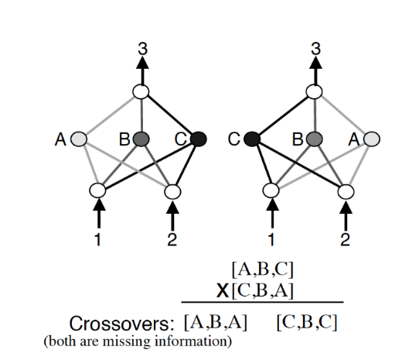
https://miro.medium.com/max/700/0*AlgDyVgxlUCOlE0B.png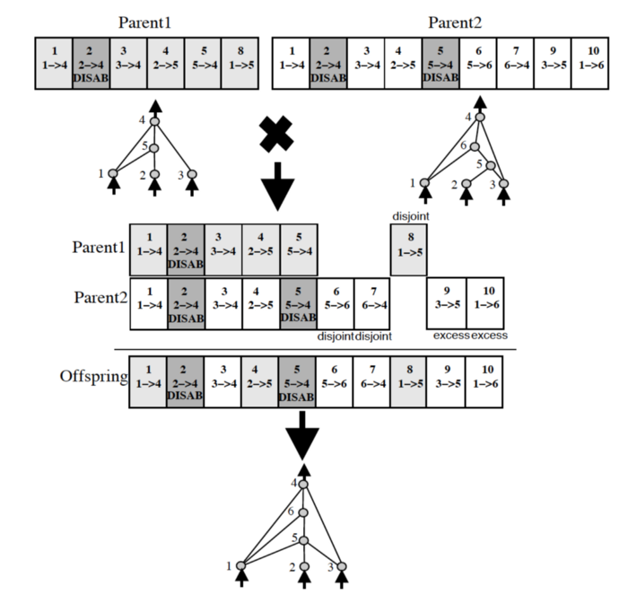
https://miro.medium.com/max/700/0*N4j_sl8M05G6pXZV.png
Crossover takes two parents and “Crosses” them where we use a Dominant/Recessive chance to pass on different genetics to children nodes. So, for example here is some pseudo code:
If (Gene in both parents):
Pick Random one Between them.
Else:
Child Gets Gene.

+ If Parent1 has a higher fitness score than Parent2,
- Mutation
Chance to change a gene.
- Create/Remove NodeGene_t:
  - Create: requires taking existing Edge and splitting in two.
  - Remove: Simply remove Node from list.

- Increase/Decrease weight in Gene:
  - Set Disabled flag to TRUE.

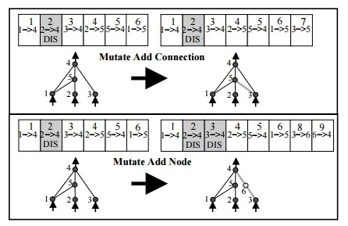
https://miro.medium.com/max/446/0*hk8JqrWFbRiG04L2.jpg
Add new node steps:
- If no edges exist, create one from input to output
- Select an existing edge, and create node from

Works Cited:

Future Work:
+Take NEAT and modify it for larger neural networks, so each ‘Node’ is a Block of neurons, each network is trained with back propagation.

